Delay, Loss Throughput, OSI Layers
  - Chapter 1.4-1.7 to accompany slides.

1.4 Delay Loss and Throughput
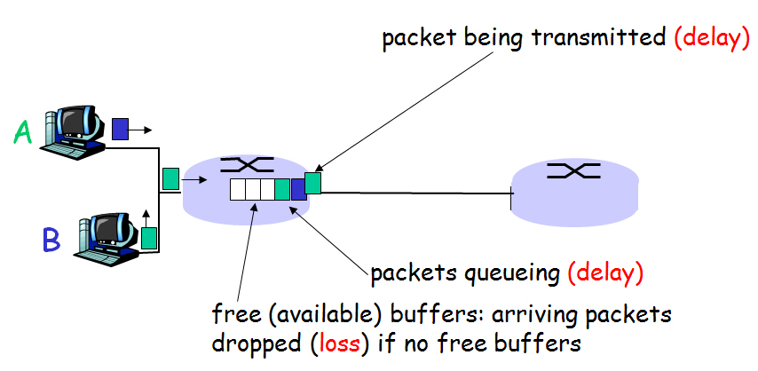
Slide: Figure 1.16

1.4.1 Delay overview
Trivia: There exists Delay Loss and constraints on throughput such that 100s of Ph.D. dissertations have been written on these topics.
Def: Nodal Delay starts when a packet arrives at a node (router) and ends when that packet has arrived at the next node (router | host). Nodal Delay is made up of:
- (Nodal) Processing Delay (usually on the order of microseconds e.g. 5 microseconds = 5x10^-6 seconds)
- Queuing Delay (how long is the line? Micro to milli seconds)
- Transmission delay
- Propagation delay
Processing delay is a property of the router and is given usually in microseconds. This is denoted${ d}_{proc}$.
Queuing delay depends on the amount of traffic. We will use a measure called traffic intensity, but more on traffic intensity later. This is denoted${ d}_{queue}$.
Transmission delay is the amount of time it takes for the router or host to push out the packet onto the wire. If a packet has L bits in it, and the transmission rate is R, then
$$d_{trans}=\frac{L}{R}$$
Propagation delay is simply a rate and distance question. How long does it take to get from here to there (the length of the wire) if you are traveling at wire speed.
$$d_{prop}=\frac{d}{s}$$
Usually the speed is $2×{10}^{8}$ meters per second for electricity or $3×10^8$ meters per second for light or electromagnetic radiation such as wireless.
So we have that nodal delay is given as
$$d_{nodal}=d_{proc}+d_{queue}+d_{trans}+d_{prop}$$
Q: In what situations can you think of that each of these might dominate? Is there one that will probably never dominate?

1.4.2 Queuing delay and packet loss
The most complicated and interesting delay is $d_{queue}$.
Several books have been written on this topic alone!
Queuing delay varies from packet to packet.
Q: If ten packets arrive simultaneously to the same queue, the first packet has $d_{queue}=0$. If the packets are all of length $L$ and the transmission rate is $R$, what is the delay of the 10th packet?
A: Packet number 10 has to wait for each packet to be transmitted. Since each packet takes $L/R$ time to transmit (we don’t care about the propagation time), the wait time is $9L/R$.
Q: If there were $n$ packets?
A: $\left(n-1\right)L/R$.
Clearly at this point you can see that the amount of wait time depends on the arrival rate and the transmission rate.
Let $a$ denote the arrival rate of packets (units = packets / second), then the average rate at which bits arrive is $La$, where $L$ is bits/packet such that $La$ has units of bits/second. The way to determine traffic intensity is to look at the ratio of incoming bits to outgoing bits. We denote traffic intensity by
$$I=\frac{La}{R}$$
If incoming bits are arriving faster than outgoing bits, then $I>1$ and you will eventually fill up the queue and the router will drop packets for queues that are full.
If $I<1$ we will shrink the queue and life is good.
If $I=1$, watch out, no mistakes can be made and life is frantic.

1.4.3 End-to-end delay
Example: $N-1$ routers separate two hosts where the network is uncongested, then
$$d_{end-to-end}=N(d_{proc}+d_{trans}+d_{prop})$$
Example: Short trace route end-to-end example.
Other end-to-end delays: For dialup: modulation encoding delays, for VoIP: packetization delay…

1.4.4 Throughput in computer networks (use slides 56-58 of the publisher)
Def: Instantaneous throughput at any instant of time is the rate (in bits/sec) at which the receiving host is receiving the file.
Def: Average throughput for a large file of size $F$ which takes a total of time $T$ to receive is $F/T$.

1.5 Protocol Layers and service models (use slides 60-66 of the publisher)

1.6 Not covered – join network security

1.7 Time permitting
Internet turns 40 Labor day 2009!

